Test Case: tc002_SPX_Dev5_Crear_Requisicion_Spot_Con_FAD_Tipo_Cobro_CC
Step 1 - Enter username and password and click to button Enter : Credentials Entered
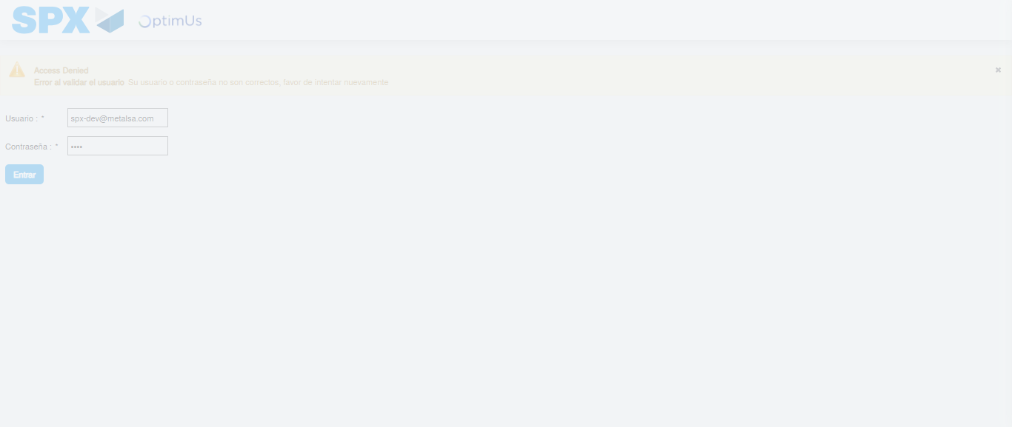Image file-name: QC_Testing-tc002_SPX_Dev5_Crear_Requisicion_Spot_Con_FAD_Tipo_Cobro_CC-1782314427985

Step 2 - Select to UEN and Access to Spot Buy Requisitions : UEN Correctly selected and Correct access
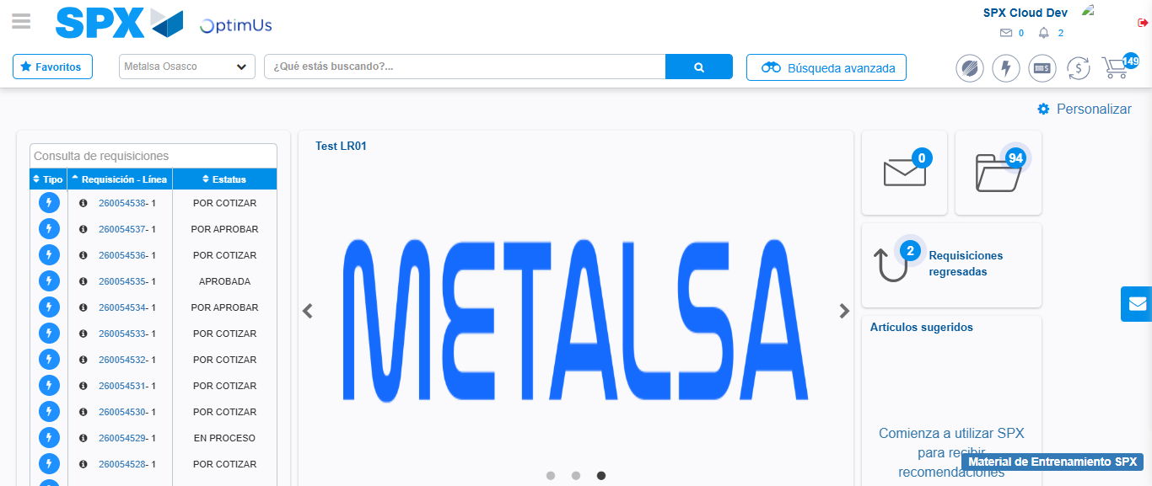Image file-name: QC_Testing-tc002_SPX_Dev5_Crear_Requisicion_Spot_Con_FAD_Tipo_Cobro_CC-1782314498836

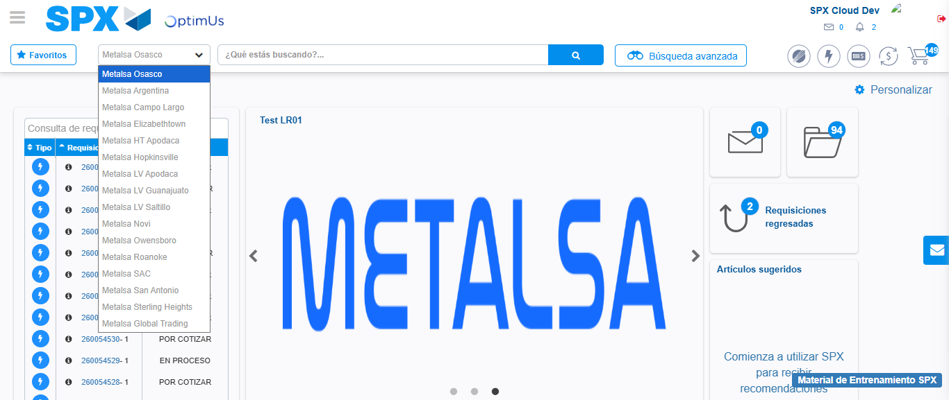Image file-name: QC_Testing-tc002_SPX_Dev5_Crear_Requisicion_Spot_Con_FAD_Tipo_Cobro_CC-1782314501602

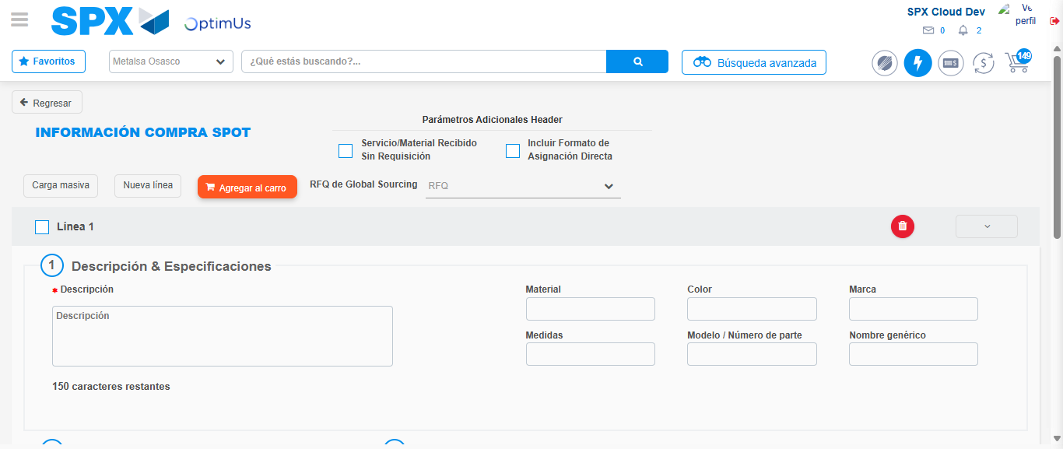Image file-name: QC_Testing-tc002_SPX_Dev5_Crear_Requisicion_Spot_Con_FAD_Tipo_Cobro_CC-1782314511150

Step 3 - Add FAD to Requisition: FAD Successfully Added
Image file-name: QC_Testing-tc002_SPX_Dev5_Crear_Requisicion_Spot_Con_FAD_Tipo_Cobro_CC-1782314511505

Image file-name: QC_Testing-tc002_SPX_Dev5_Crear_Requisicion_Spot_Con_FAD_Tipo_Cobro_CC-1782314511765

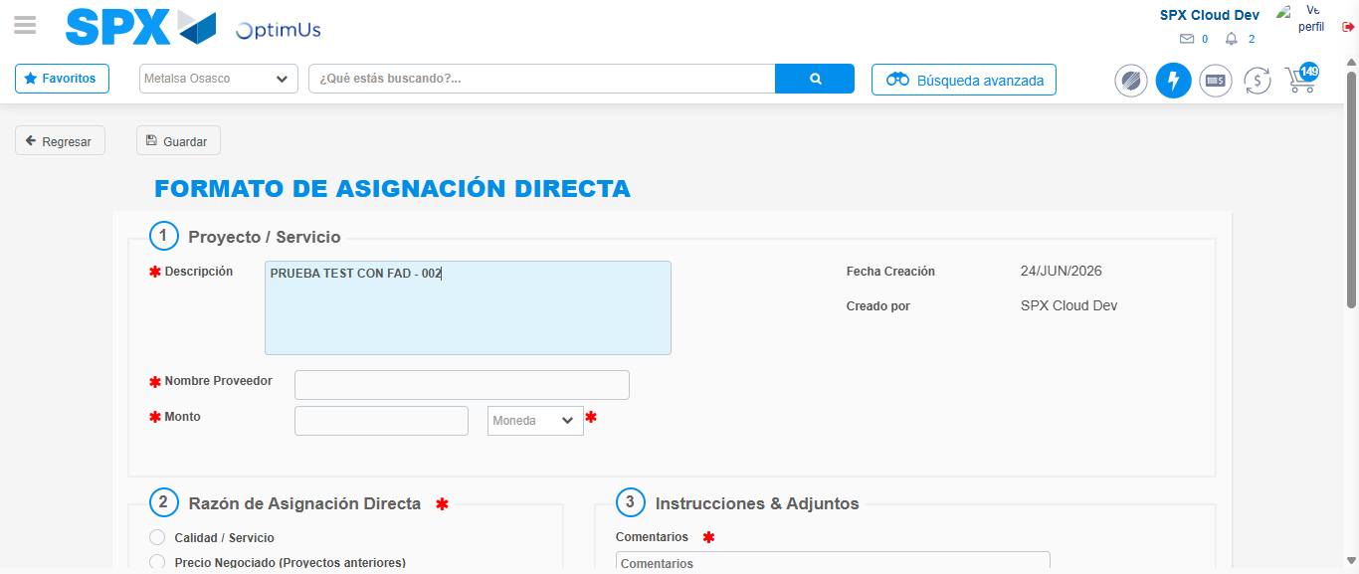Image file-name: QC_Testing-tc002_SPX_Dev5_Crear_Requisicion_Spot_Con_FAD_Tipo_Cobro_CC-1782314514705

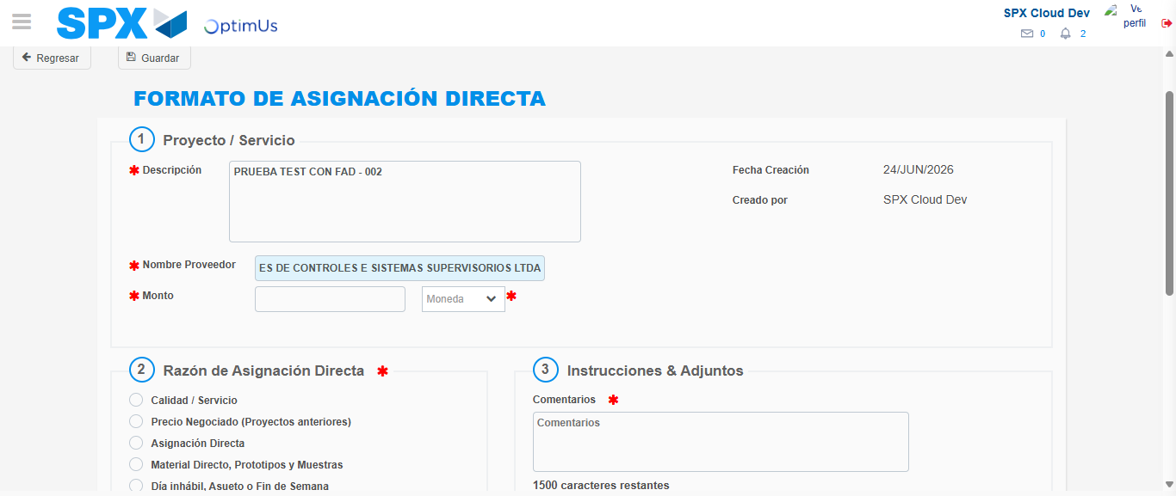Image file-name: QC_Testing-tc002_SPX_Dev5_Crear_Requisicion_Spot_Con_FAD_Tipo_Cobro_CC-1782314525613

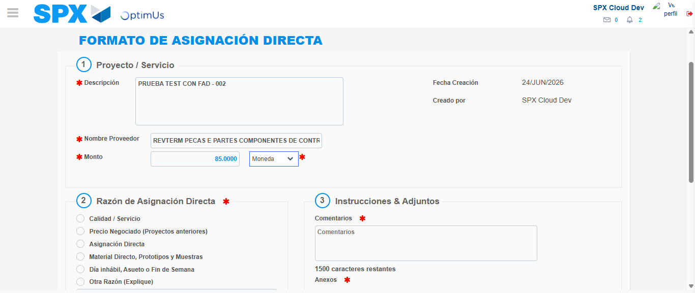Image file-name: QC_Testing-tc002_SPX_Dev5_Crear_Requisicion_Spot_Con_FAD_Tipo_Cobro_CC-1782314526244

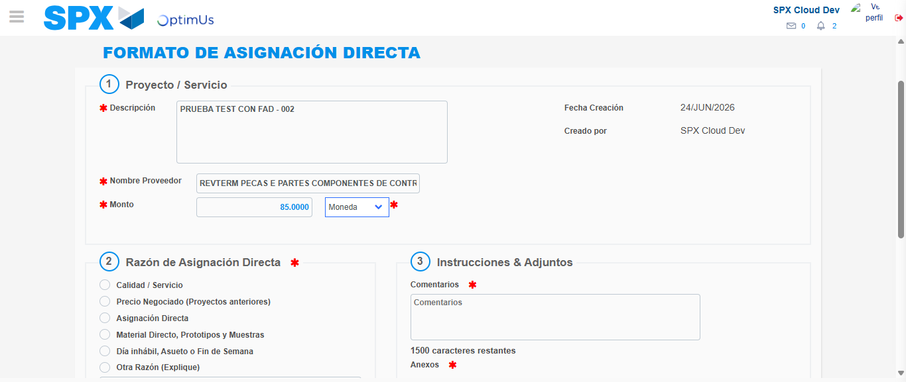Image file-name: QC_Testing-tc002_SPX_Dev5_Crear_Requisicion_Spot_Con_FAD_Tipo_Cobro_CC-1782314526507

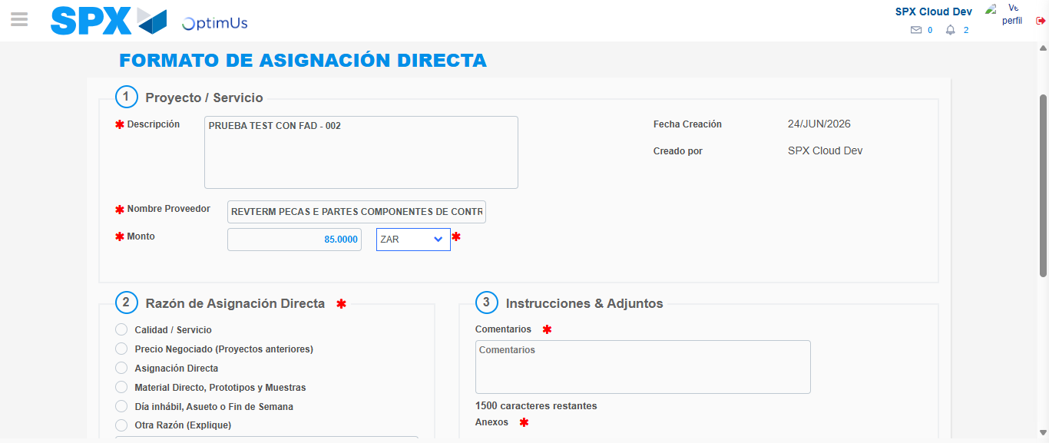Image file-name: QC_Testing-tc002_SPX_Dev5_Crear_Requisicion_Spot_Con_FAD_Tipo_Cobro_CC-1782314527134

Image file-name: QC_Testing-tc002_SPX_Dev5_Crear_Requisicion_Spot_Con_FAD_Tipo_Cobro_CC-1782314527396

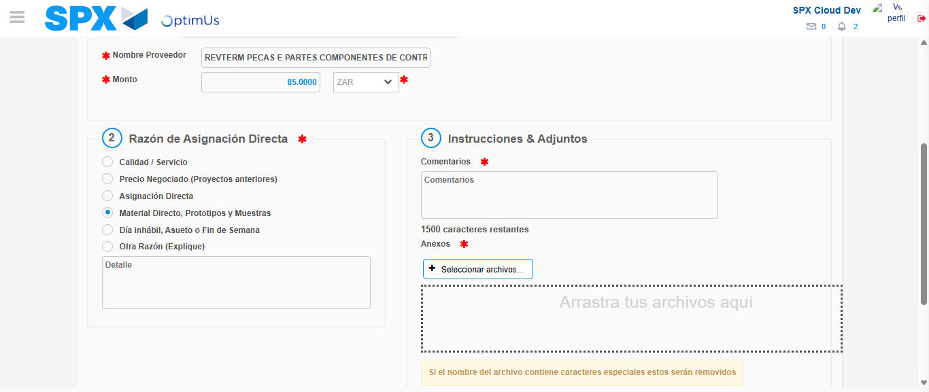Image file-name: QC_Testing-tc002_SPX_Dev5_Crear_Requisicion_Spot_Con_FAD_Tipo_Cobro_CC-1782314528447

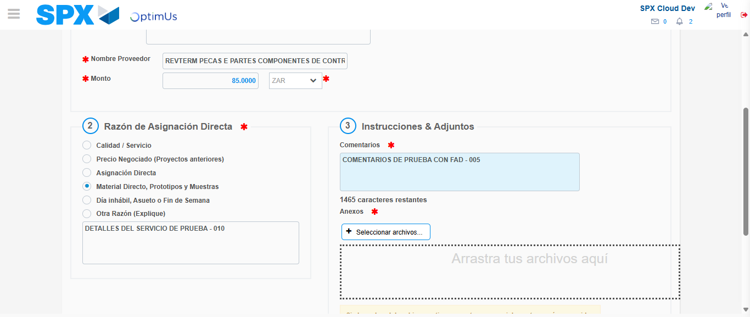Image file-name: QC_Testing-tc002_SPX_Dev5_Crear_Requisicion_Spot_Con_FAD_Tipo_Cobro_CC-1782314539620

Image file-name: QC_Testing-tc002_SPX_Dev5_Crear_Requisicion_Spot_Con_FAD_Tipo_Cobro_CC-1782314540674

Step 4 - Data Capture Spot Buy Requisition: Data captured correctly
Image file-name: QC_Testing-tc002_SPX_Dev5_Crear_Requisicion_Spot_Con_FAD_Tipo_Cobro_CC-1782314511505

Image file-name: QC_Testing-tc002_SPX_Dev5_Crear_Requisicion_Spot_Con_FAD_Tipo_Cobro_CC-1782314511765

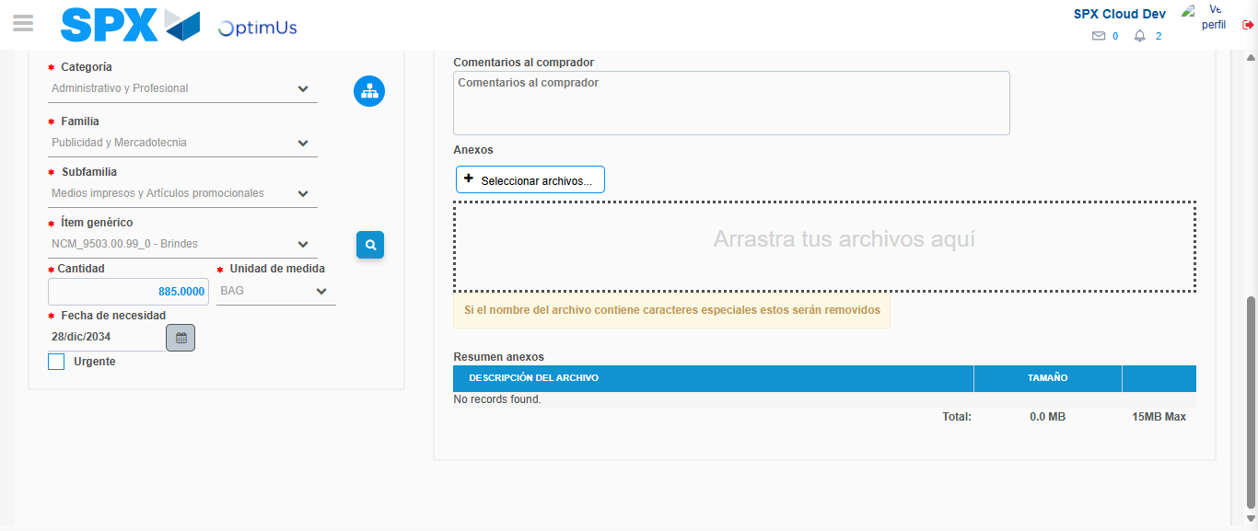Image file-name: QC_Testing-tc002_SPX_Dev5_Crear_Requisicion_Spot_Con_FAD_Tipo_Cobro_CC-1782314556212

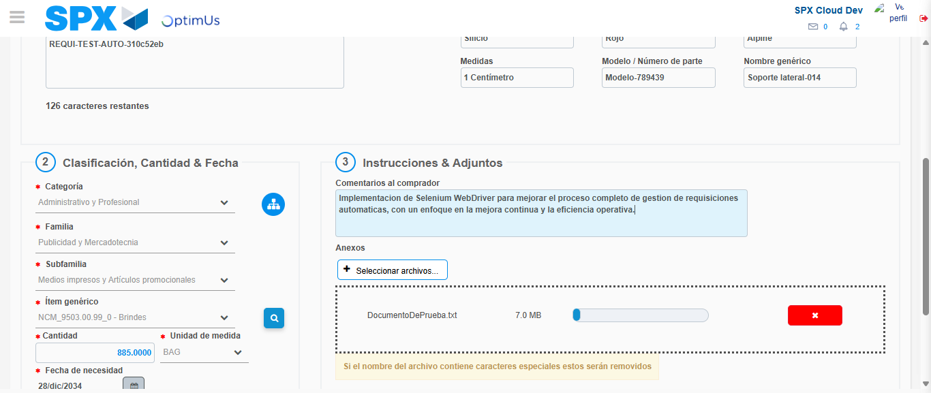Image file-name: QC_Testing-tc002_SPX_Dev5_Crear_Requisicion_Spot_Con_FAD_Tipo_Cobro_CC-1782314557184

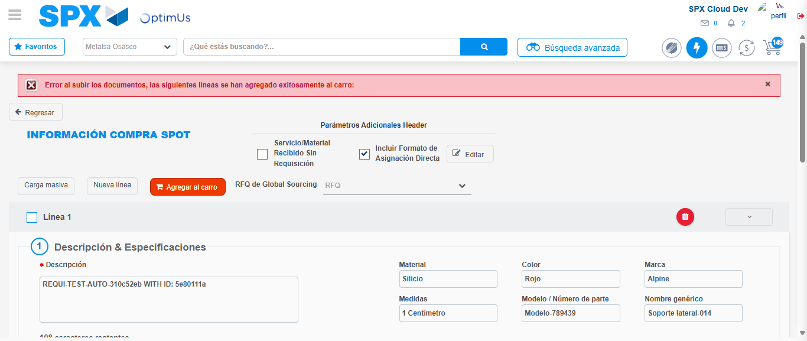Image file-name: QC_Testing-tc002_SPX_Dev5_Crear_Requisicion_Spot_Con_FAD_Tipo_Cobro_CC-1782314569316

Step 8 - Return to Main Page SPX : Return to Main Page SPX
Image file-name: QC_Testing-tc002_SPX_Dev5_Crear_Requisicion_Spot_Con_FAD_Tipo_Cobro_CC-1782314498836

Image file-name: QC_Testing-tc002_SPX_Dev5_Crear_Requisicion_Spot_Con_FAD_Tipo_Cobro_CC-1782314501602

Image file-name: QC_Testing-tc002_SPX_Dev5_Crear_Requisicion_Spot_Con_FAD_Tipo_Cobro_CC-1782314511150

Image file-name: QC_Testing-tc002_SPX_Dev5_Crear_Requisicion_Spot_Con_FAD_Tipo_Cobro_CC-1782314571628

Image file-name: QC_Testing-tc002_SPX_Dev5_Crear_Requisicion_Spot_Con_FAD_Tipo_Cobro_CC-1782314571861

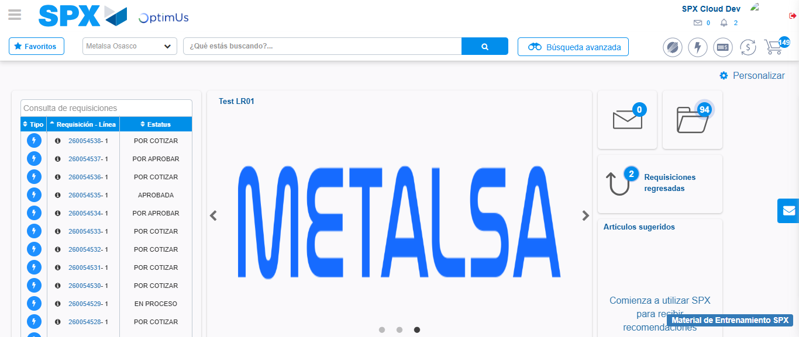Image file-name: QC_Testing-tc002_SPX_Dev5_Crear_Requisicion_Spot_Con_FAD_Tipo_Cobro_CC-1782314593194

Step 9 - Log Out : Log Out SPX
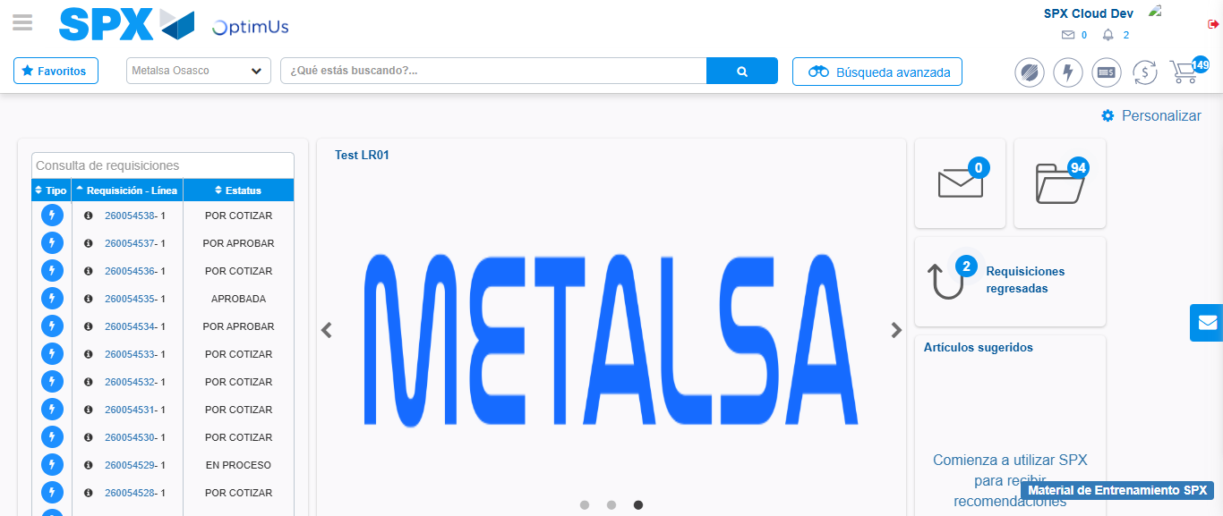Image file-name: QC_Testing-tc002_SPX_Dev5_Crear_Requisicion_Spot_Con_FAD_Tipo_Cobro_CC-1782314593521

